Name: ___**Sean Lantto_**_

**MAE 493G/ CpE 493M Mobile Robotics, Spring 2017**

**Homework #4 (10 Points)**

**Assigned: 02/10/2017 Due: 02/17/2017**

*Note: please properly document your homework (including MATLAB code) in a****Microsoft Word*** *file and upload it to* ***eCampus****.*

**Problem #1 (3 Points)**

You are rolling two fair dice and writing down the combined number.

1. What is the sample space for each attempt?

**Answer: 36 possibilities per roll**

1. What is the probability that you are getting a 7?

**Answer: 6 possible ways to get a 7, thus the probability is 6/36 or 1/6**

1. What is the probability that you are getting 7 twice during two rolls?

**Answer: The chance of getting a 7 in a roll is 1/6, and for two rolls in a row it is 1/6*1/6=1/36**

**Problem #2 (3 Points)**

A student traditionally showed up late to class 30% of the time. The probability that this student would be late for class if the PRT breaks down is 0.9. The probability of the PRT system breaking down is 0.1.

1. Known that the student is late for class today, what is the probability that the PRT system is down?

**Answer: The probability of the PRT being down if the student is late is a joint probability, and is the product of the probability the student will be late if PRT is down and the probability of the PRT being down. 0.9*0.1=0.09. There is a 9% chance the PRT will be down if the student is late.**

1. What is the probability that the student will be late for class if the PRT is running OK?

**Answer: Using the law of total probability**

**(Pr(Late)=Pr(late&PRT down)+ Pr(late&PRT up)**

**0.3=0.09+Pr(late&PRT up), Pr(late&PRT up)=0.21 or 21% chance student is late and the PRT is up**

**Problem #3 (2 Points)**

Use MATLAB to plot the likelihood function for estimating the probability of a coin landing heads-up without prior knowledge after observing HH (i.e., head and head). Also plot the likelihood function after observing HHT (Check the class slides!).

**Answer: The code for Problem 3 is attached below along with desired plots**

%Problem 3

%Likelihood of a coin landing heads up after observing HH

%Heads = Ph

%Tails = 1-Ph

clear

close all

clc

Ph=0:0.1:1;

%part 1 HH

L=Ph.^2;

figure;

plot(Ph,L)

xlabel('Ph')

ylabel('Likelihood')

title('HH')

%Part 2 HHT

L=(Ph.^2).*(1-Ph);

figure;

plot(Ph,L)

xlabel('Ph')

ylabel('Likelihood')

title('HHT')

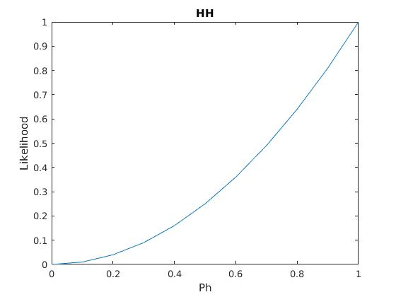

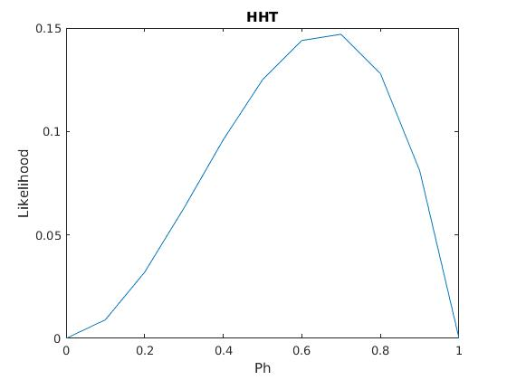

**Problem #4 (2 Points)**

Imagine we have three types of coins in a bag: Fair Coin (FC) with Pr(Head) = Pr(Tail) = 0.5; Head-heavy Coin (HC) with Pr(Head) = 0.6; and Tail-heavy Coin (TC) with Pr(Head) = 0.40. A coin is randomly picked out of the bag. Write a MATLAB code that can estimate the type of this coin (Check the class slides!).

**Answer: The code for Problem 4 is attached below along with desired plots**

%Problem 4

%Coin type estimator

clear

%set up initial parameters

PrFC=1/3;

PrTC=1/3;

PrHC=1/3;

PrhFC=0.5;PrtFC=0.5;

PrhTC=0.4;PrtTC=0.6;

PrhHC=0.6;PrtHC=0.4;

coin=round(rand(400,1));

%Tails = 0,Heads = 1

for i=1:length(coin)

if coin(i) == 1

PrFCh=PrhFC*PrFC;

PrTCh=PrhTC*PrTC;

PrHCh=PrhHC*PrHC;

normalize=1/(PrFCh+PrTCh+PrHCh);

PrFC=PrFCh*normalize;

PrTC=PrTCh*normalize;

PrHC=PrHCh*normalize;

elseif coin(i) == 0

PrFCh=PrtFC*PrFC;

PrTCh=PrtTC*PrTC;

PrHCh=PrtHC*PrHC;

normalize=1/(PrFCh+PrTCh+PrHCh);

PrFC=PrFCh*normalize;

PrTC=PrTCh*normalize;

PrHC=PrHCh*normalize;

end

FC(i)=PrFC;

TC(i)=PrTC;

HC(i)=PrHC;

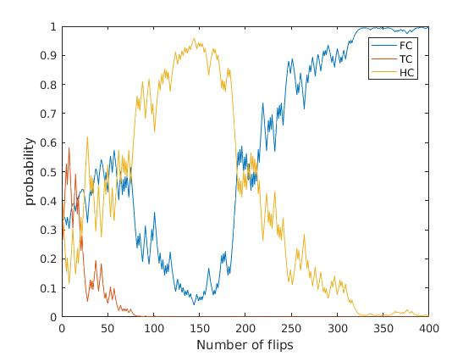end

